# Erin’s study case

Efix



This is the one in GC

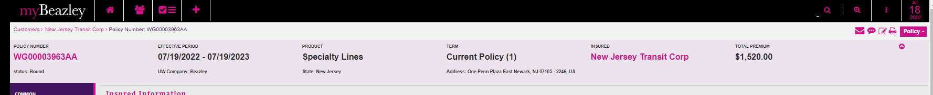

Let’s make a Revised Binder to change the Broker License without affecting the premium.

Other change to Teresa…

